**Wk10 Assignment: RDBMS and SQL**

# Problem Statement

• Create one to many and many to one Bidirectional mapping for student and university

• Insert the records using stored procedure

• Write a user defined function to find out total number of students

• Using subqueries list out all the students who are studying in specific university

• List out all the students who is studying in specific university using joins.

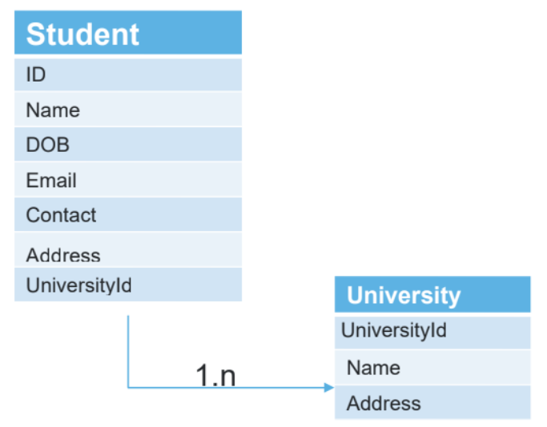

# Solution

## Create one to many and many to one Bidirectional mapping for student and university

CREATE TABLE University (

UniversityID INT PRIMARY KEY,

Name VARCHAR(40),

Address VARCHAR(100)

);

**____________________________________________**

CREATE TABLE Student (

StudentID INT PRIMARY KEY,

Name VARCHAR(50),

DOB DATE,

Email VARCHAR(50),

Contact BIGINT(10),

Address VARCHAR(100),

UniversityID INT,

FOREIGN KEY (UniversityID) REFERENCES University(UniversityID)

);

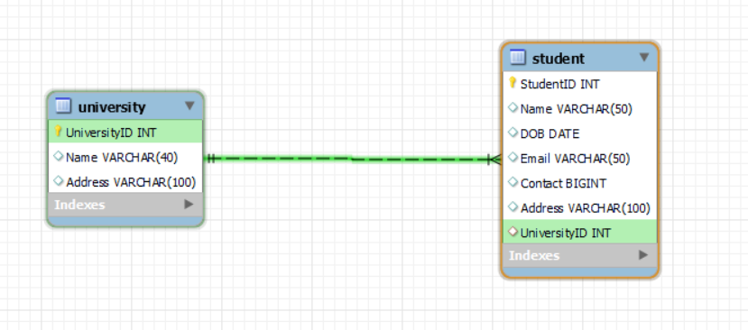

## Insert the records using stored procedure

### Create procedures

DELIMITER //

CREATE PROCEDURE InsertStudentData(

IN p_StudentID INT,

IN p_Name VARCHAR(50),

IN p_DOB DATE,

IN p_Email VARCHAR(50),

IN p_Contact BIGINT,

IN p_Address VARCHAR(100),

IN p_UniversityID INT

)

BEGIN

INSERT INTO Student (StudentID, Name, DOB, Email, Contact, Address, UniversityID)

VALUES (p_StudentID, p_Name, p_DOB, p_Email, p_Contact, p_Address, p_UniversityID);

END //

DELIMITER ;

**_____________________________________________________________**

DELIMITER //

CREATE PROCEDURE InsertUniversityData(

IN p_UniversityID INT,

IN p_Name VARCHAR(40),

IN p_Address VARCHAR(100)

)

BEGIN

INSERT INTO University (UniversityID, Name, Address)

VALUES (p_UniversityID, p_Name, p_Address);

END //

DELIMITER ;

### Insert University data

CALL InsertUniversityData(1, 'ABC University', 'Agra');

CALL InsertUniversityData(2, 'Technical University', 'Delhi');

CALL InsertUniversityData(3, 'Anand Science University', 'Kolkata');

CALL InsertUniversityData(4, 'National University', 'Banglore');

CALL InsertUniversityData(5, 'Rastriya Science University', 'Chennai');

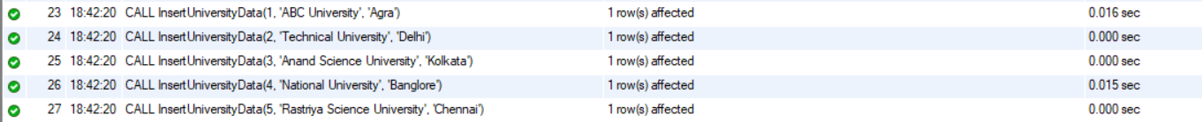

select * from rdbms_sql_demo.university;

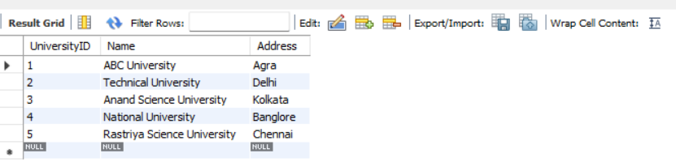

### Insert Student data

CALL InsertStudentData(1, 'Arjun Sharma', '1998-07-15', 'arjun.sharma@gmail.com', 9876543210, '123 Rajpath, New Delhi', 1);

CALL InsertStudentData(2, 'Priya Gupta', '2001-02-28', 'priya.gupta@yahoo.com', 9987654321, '456 MG Road, Mumbai', 2);

CALL InsertStudentData(3, 'Aditya Kapoor', '1997-11-05', 'aditya.kapoor@outlook.com', 9012345678, '789 Chandni Chowk, Kolkata', 3);

CALL InsertStudentData(4, 'Neha Sharma', '2000-04-22', 'neha.sharma@gmail.com', 8765432109, '321 Civil Lines, Chennai', 4);

CALL InsertStudentData(5, 'Raj Malhotra', '1999-09-08', 'raj.malhotra@outlook.com', 8901234567, '654 Connaught Place, New Delhi', 5);

CALL InsertStudentData(6, 'Simran Kaur', '2002-06-01', 'simran.kaur@yahoo.com', 7654321098, '987 Brigade Road, Bangalore',2);

CALL InsertStudentData(7, 'Karan Chopra', '1998-12-31', 'karan.chopra@gmail.com', 6543210987, '159 Park Street, Kolkata', 2);

CALL InsertStudentData(8, 'Pooja Verma', '2001-05-18', 'pooja.verma@gmail.com', 5432109876, '753 MG Road, Chennai', 4);

CALL InsertStudentData(9, 'Nikhil Mehta', '2000-03-27', 'nikhil.mehta@outlook.com', 4321098765, '951 Janpath, New Delhi', 5);

CALL InsertStudentData(10, 'Riya Khanna', '1999-08-11', 'riya.khanna@gmail.com', 3210987654, '357 Linking Road, Mumbai', 3);

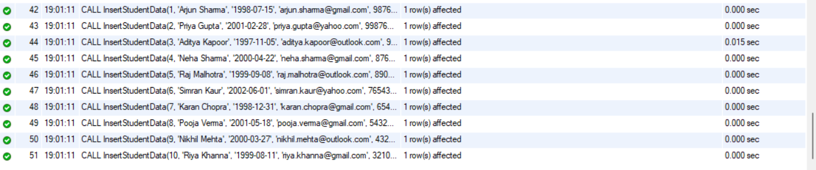

SELECT * FROM rdbms_sql_demo.student;

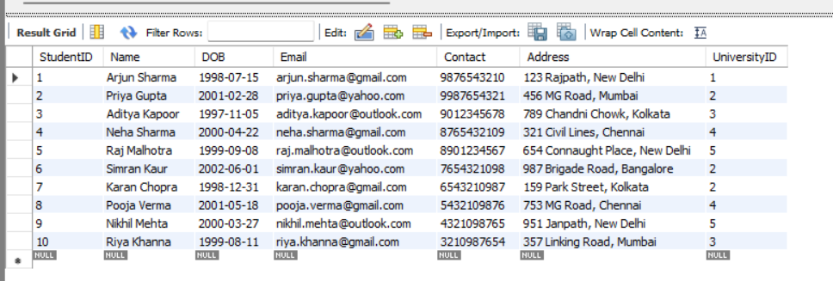

## Write a user defined function to find out total number of students

### Create function

DELIMITER //

CREATE FUNCTION GetTotalStudents()

RETURNS INT

BEGIN

DECLARE total_students INT;

SELECT COUNT(*) INTO total_students FROM Student;

RETURN total_students;

END //

DELIMITER ;



### Use function

SELECT GetTotalStudents();



## Using subqueries list out all the students who are studying in specific university

SELECT * FROM Student

WHERE UniversityID = (

SELECT UniversityID

FROM University

WHERE Name = 'Technical University'

);

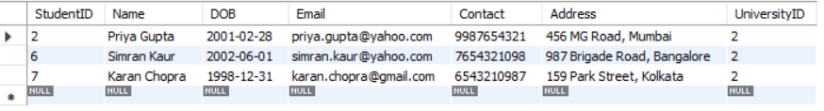

## List out all the students who is studying in specific university using joins.

SELECT s.*, u.Name AS UniversityName, u.Address AS UniversityAddress

FROM Student s

JOIN University u ON s.UniversityID = u.UniversityID

WHERE u.Name = 'National University';

